**Deploy Multiple Application to Docker using docker-compose**

**Step1:**

Create Multiple Spring boot applications (Hello world spring boot application, sample application as WAR file)

**Step2:**

Create Ubuntu virtual machine from azure portal

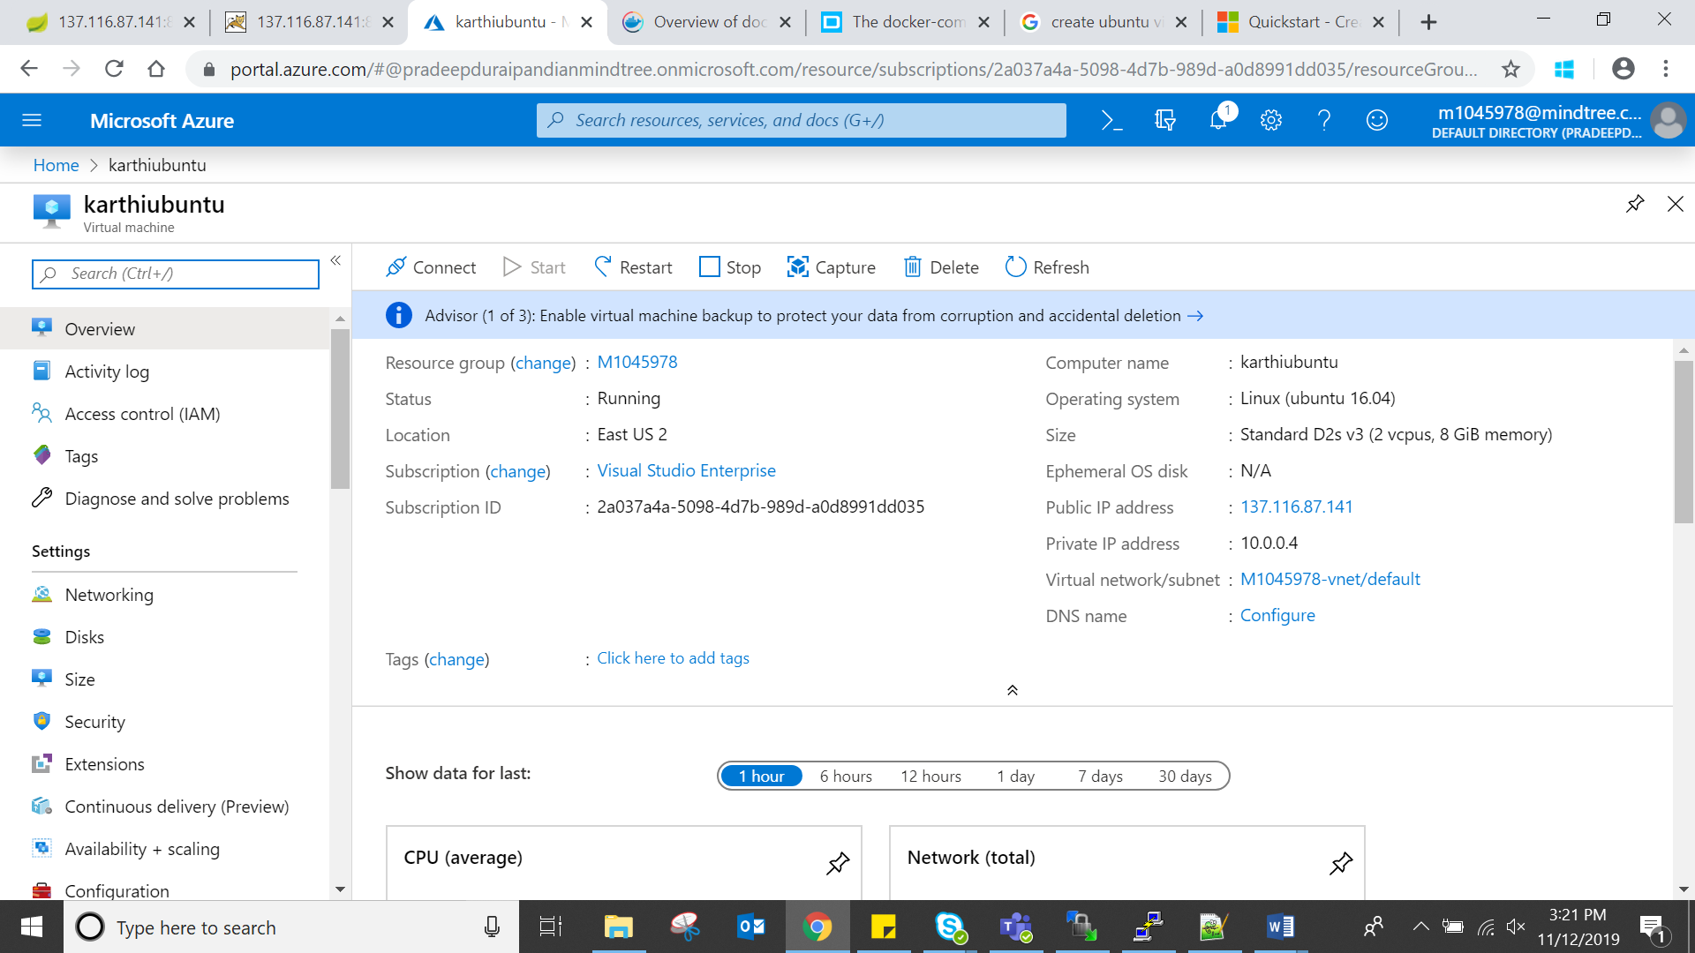

**Step3:**

Login into Ubuntu VM through putty (username & Password)

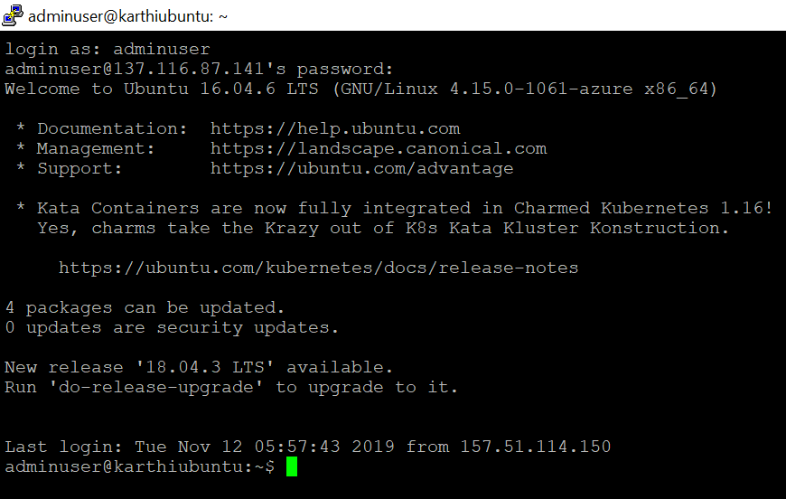

**Step4:**

Install the docker using docker commands



**Step5:**

Using WINSCP, create two folders inside the ubuntu VM as Project & War

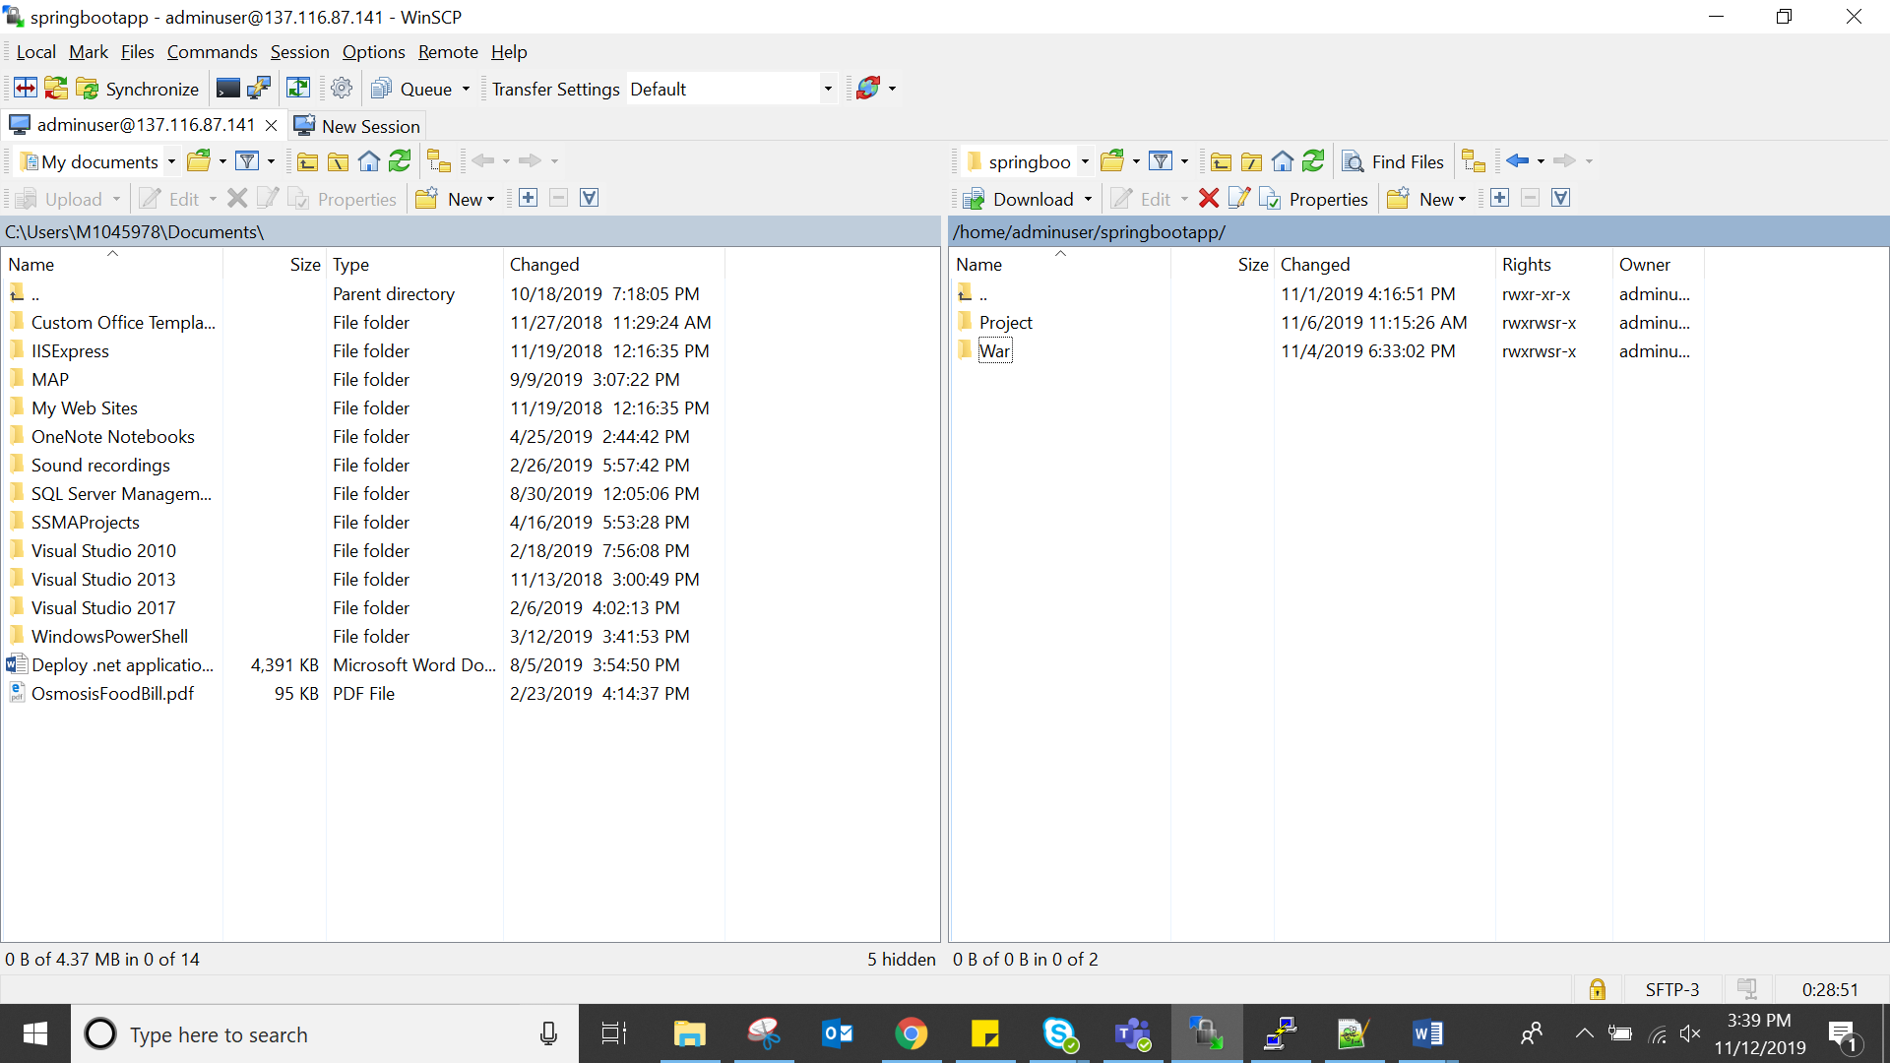

Copy the spring boot application and WAR from local machine and paste the folder accordingly

Inside the Project folder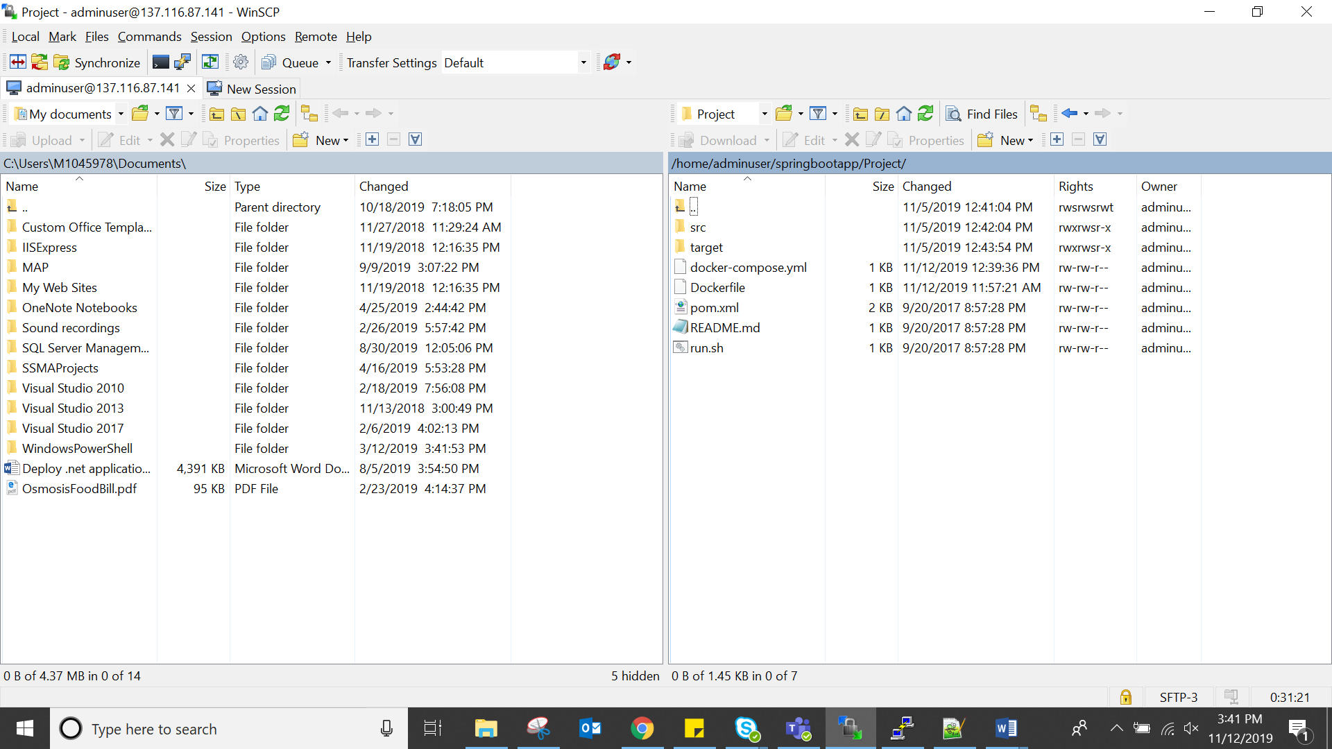

Inside War folder

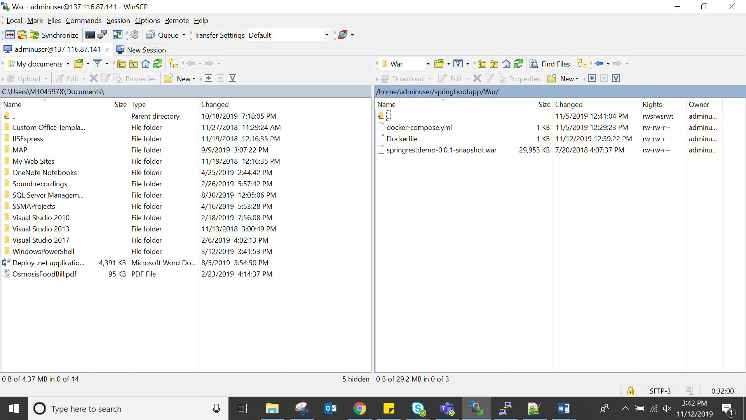

**Step6:**

**Docker file for War**



**Docker file for spring boot application**



**Step7:**

Build the war file as docker image using docker commands

Note: Make sure you are in War directory, following commands to move War folder after login

**Cd War**

**Sudo su –** giving permission to this folder

Following commands to build the War file as docker images

**docker build --tag "warproject8081port" .**

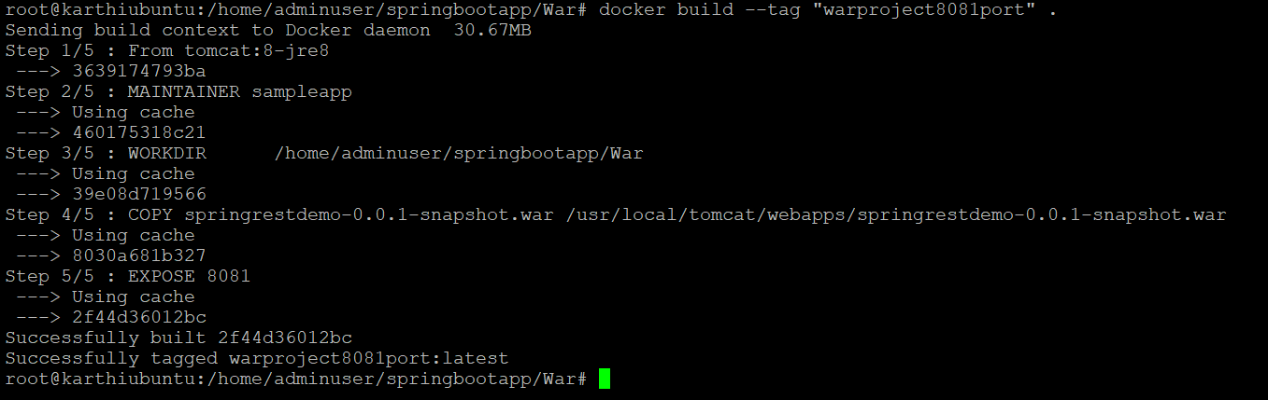

Same as War file, build the spring boot application as docker images

**docker build --tag "springbootapp8080port" .**

To check whether the War file converted as docker image

**docker images**



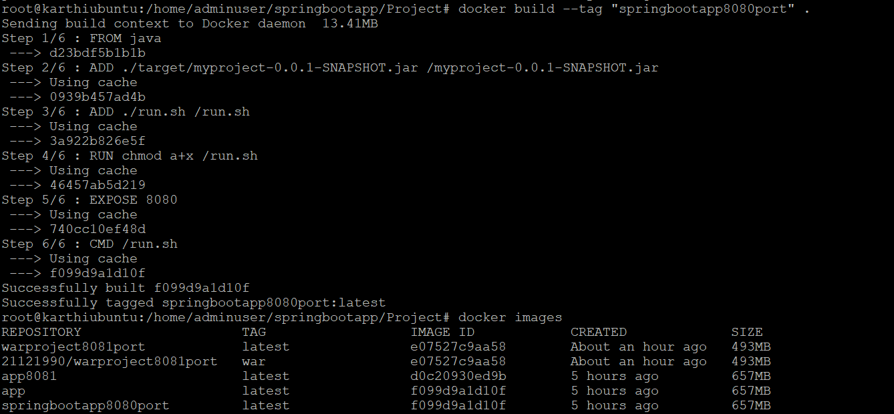

**Step8:**

Push docker image into docker hub repository

Note: before push into docker hub, make sure that already login into docker by following command

**docker login**

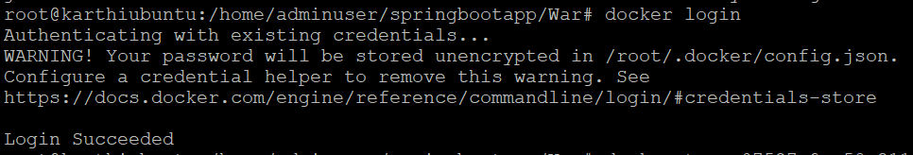

**docker push 21121990/warproject8081port**

**Below mentioned the details**

**21121990 –** Username of docker hub

**warproject8081port –** docker image name

Same as War, push springbootapp docker image into docker hub

**docker tag f099d9a1d10f 21121990/springbootapp8080port:app**

**docker push 21121990/springbootapp8080port**

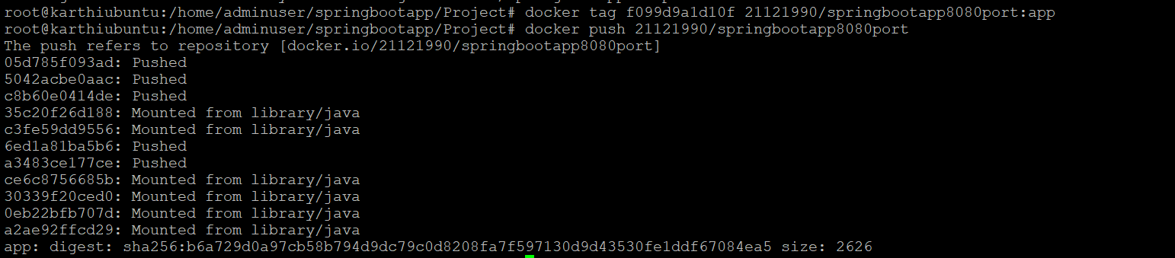

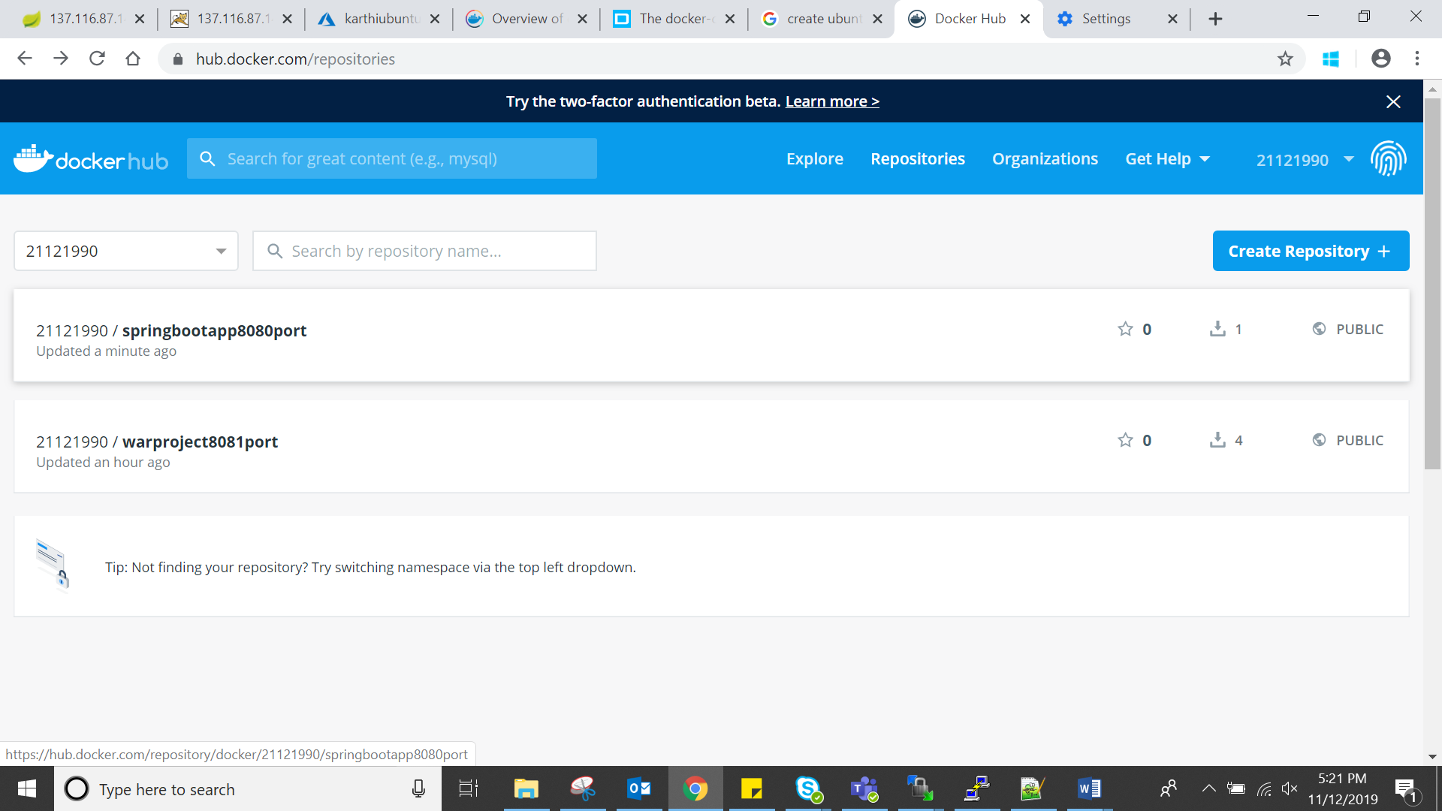

**Step9:**

Configure the YML file, which contains two services with two different ports (8080, 8081)

The YML file has following commands



Run the following commands to deploy the YML file

**docker-compose up**

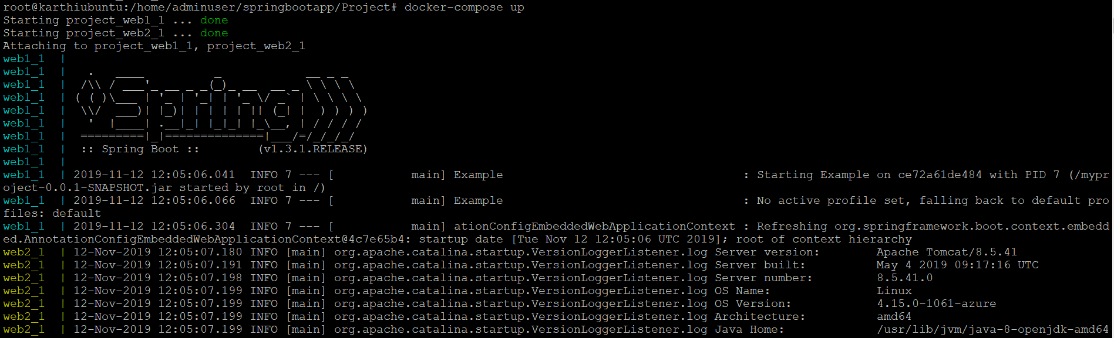

**Step10:**

Check the Deployed applications through IP Address of VM with PORT

War Project with port 8081

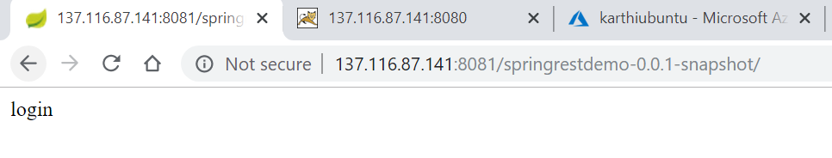

Spring boot application with port 8080

